# Apply filters to SQL queries

## Project description

Aplicar filtros como WHERE, AND, OR, NOT en sentencias SQL.

## Retrieve after hours failed login attempts

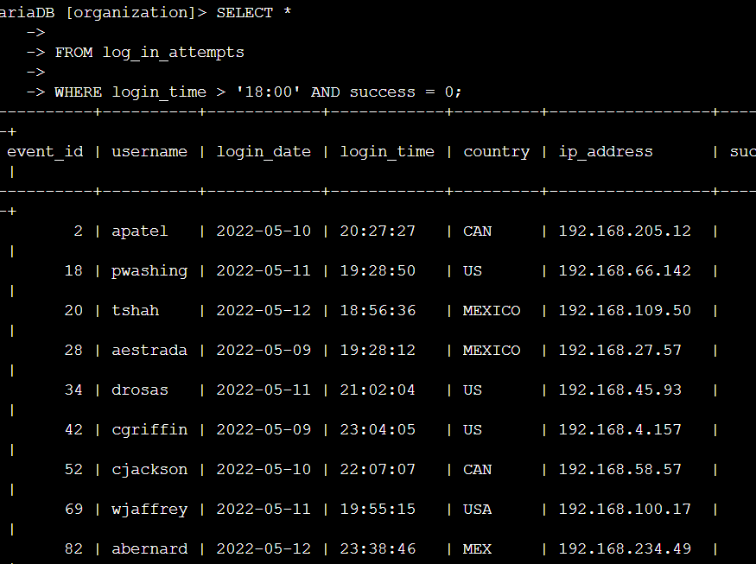

## Retrieve login attempts on specific dates

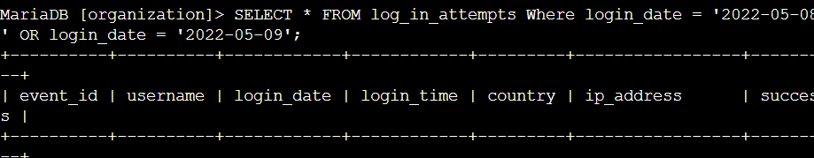

## Retrieve login attempts outside of Mexico

[Add content here.]

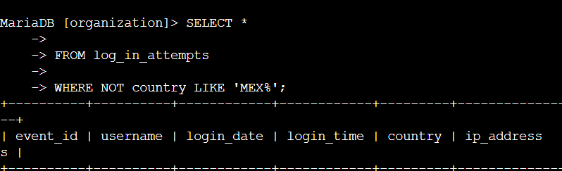

## Retrieve employees in Marketing

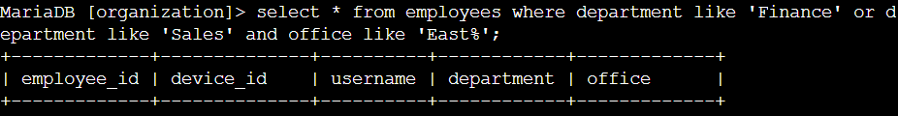+

## Retrieve employees in Finance or Sales

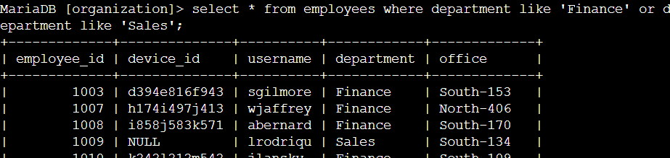

## Retrieve all employees not in IT

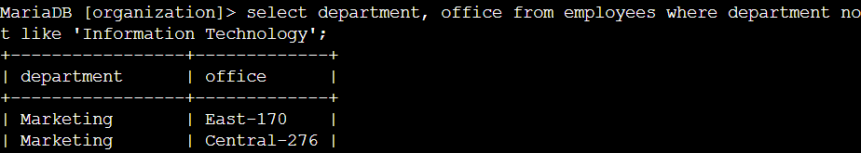

## Summary

Se filtraron resultados de búsquedas SQL según requería el problema.